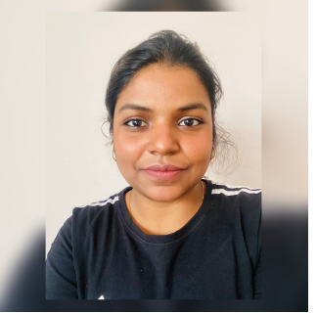

Contact

**Address:**

72/14 sadanand nagar,Harjinder nagar,Kanpur-7,up

**Phone:**

7767983592

**Email:**

[rubipgm48@gmail.com](mailto:rubipgm48@gmail.com)

**LinkedIn:**

linkedin.com/rashmivirsingh/

Languages

English

Hindi

Hobbies

* cooking
* Sketching

Summary

I am a software engineer with two years of experience, looking for opportunities in python. Skilled in Python3, OOPS,MySQL.Hands-on experience in engaging in SLDC, Test-driven development in an agile environment.

Skill Highlights

|  |  |
| --- | --- |
| * Training and self-improvement * Flexible in taking up new challenges * problem solver | * POCs on Innovations * Enthusiastically taking up new areas of work * Service-focused |

Projects and Experience

* **QUIZ-Master:**

Python based command line application with admin and user menu with CRUD functionality for authorized user to take up quiz and get scores and admin to set up the quiz based on different topics and difficulty levels.

* **GYM membership project:**

Python based command line application with admin and member menu options where admin assigns the workout to members and members can view their plan and profile.

* **Tic-tac-toe game with Tkinter:**

Python based two player game with win, lose and draw conditions with a tkinter based GUI.

**Software Engineer** - 02/2018 to present

**LTI**, Pune

* Worked on enhancement project as a backend COBOL developer for Insurance domain.
* Worked as a manual tester for a Life400 application.

Education

B.E: **Electronics and telecommunications** - 2017

**Army Institute of technology**, Pune

Certifications

* Python (certificate of excellence): EDYODA**.**
* Programming Languages: **Python, MySQL**.
* Gold badge for python on Hackerrank.

Rashmi

Singh